**Assignment - 4**

|  |  |
| --- | --- |
| Assignment Date | 2 November 2022 |
| Student Name | M.Ramachandhran |
| Student Roll Number | 912019106013 |
| Maximum Marks | 2 Marks |

**Question-1:**

Write a code and make a connection in wokwi for ultrasonic sensor. Whenever distance is less than 100 send ‘alert’ to ibm cloud and display in device recent events.

**Solution:**

*Code:*

#include <WiFi.h>

#include <PubSubClient.h>

WiFiClient wifiClient;

String data3;

#define ORG "4yi0vc"

#define DEVICE_TYPE "nodeMcu"

#define DEVICE_ID "Assignment4"

#define TOKEN "123456789"

#define speed 0.034

#define led 14

char server[] = ORG ".messaging.internetofthings.ibmcloud.com";

char publishTopic[] = "iot-2/evt/Data/fmt/json";

char topic[] = "iot-2/cmd/home/fmt/String";

char authMethod[] = "use-token-auth";

char token[] = TOKEN;

char clientId[] = "d:" ORG ":" DEVICE_TYPE ":" DEVICE_ID;

PubSubClient client(server, 1883, wifiClient);

void publishData();

const int trigpin=5;

const int echopin=18;

String command;

String data="";

long duration;

float dist;

void setup()

{

Serial.begin(115200);

pinMode(led, OUTPUT);

pinMode(trigpin, OUTPUT);

pinMode(echopin, INPUT);

wifiConnect();

mqttConnect();

}

void loop() {

bool isNearby = dist < 100;

digitalWrite(led, isNearby);

publishData();

delay(500);

if (!client.loop()) {

mqttConnect();

}

}

void wifiConnect() {

Serial.print("Connecting to "); Serial.print("Wifi");

WiFi.begin("Wokwi-GUEST", "", 6);

while (WiFi.status() != WL_CONNECTED) {

delay(500);

Serial.print(".");

}

Serial.print("WiFi connected, IP address: "); Serial.println(WiFi.localIP());

}

void mqttConnect() {

if (!client.connected()) {

Serial.print("Reconnecting MQTT client to "); Serial.println(server);

while (!client.connect(clientId, authMethod, token)) {

Serial.print(".");

delay(500);

}

initManagedDevice();

Serial.println();

}

}

void initManagedDevice() {

if (client.subscribe(topic)) {

// Serial.println(client.subscribe(topic));

Serial.println("IBM subscribe to cmd OK");

} else {

Serial.println("subscribe to cmd FAILED");

}

}

void publishData()

{

digitalWrite(trigpin,LOW);

digitalWrite(trigpin,HIGH);

delayMicroseconds(10);

digitalWrite(trigpin,LOW);

duration=pulseIn(echopin,HIGH);

dist=duration*speed/2;

if(dist<100){

String payload = "{\"Normal Distance\":";

payload += dist;

payload += "}";

Serial.print("\n");

Serial.print("Sending payload: ");

Serial.println(payload);

if (client.publish(publishTopic, (char*) payload.c_str())) {

Serial.println("Publish OK");

}

}

if(dist>101 && dist<111){

String payload = "{\"Alert distance\":";

payload += dist;

payload += "}";

Serial.print("\n");

Serial.print("Sending payload: ");

Serial.println(payload);

if(client.publish(publishTopic, (char*) payload.c_str())) {

Serial.println("Warning crosses 110cm -- it automaticaly of the loop");

digitalWrite(led,HIGH);

}else {

Serial.println("Publish FAILED");

}

}

}

void callback(char* subscribeTopic, byte* payload, unsigned int payloadLength){

Serial.print("callback invoked for topic:");

Serial.println(subscribeTopic);

for(int i=0; i<payloadLength; i++){

dist += (char)payload[i];

}

Serial.println("data:"+ data3);

if(data3=="lighton"){

Serial.println(data3);

digitalWrite(led,HIGH);

}

data3="";

}

**WOKWI CODE:**

<https://wokwi.com/projects/346937989346099796>

OUTPUT

**Distance is greater than 100**

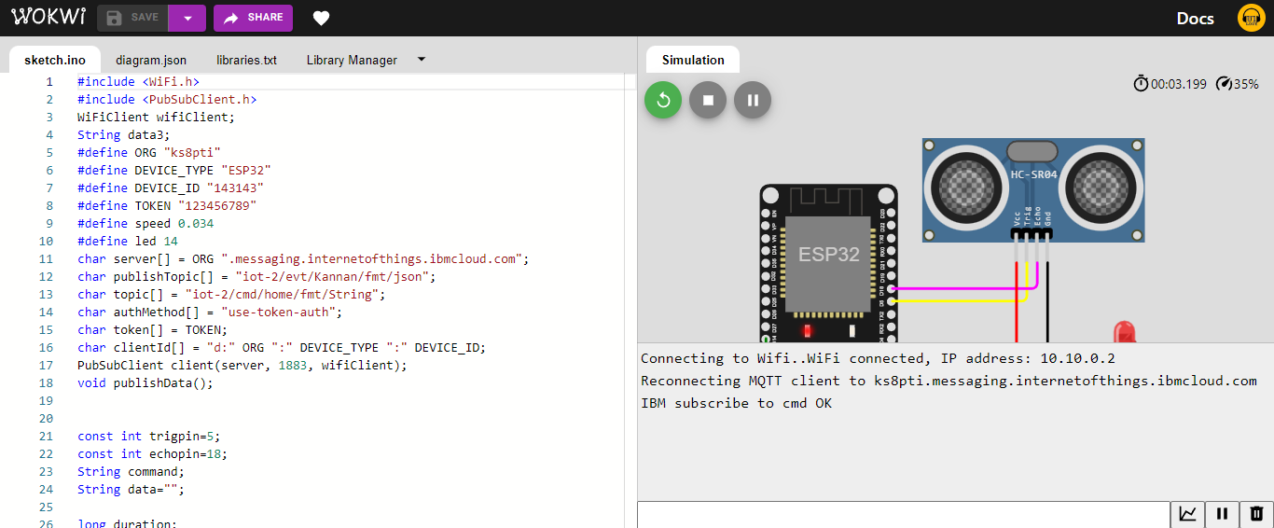

IBM cloud is connected and LED is off state

**Distance is less than 100**

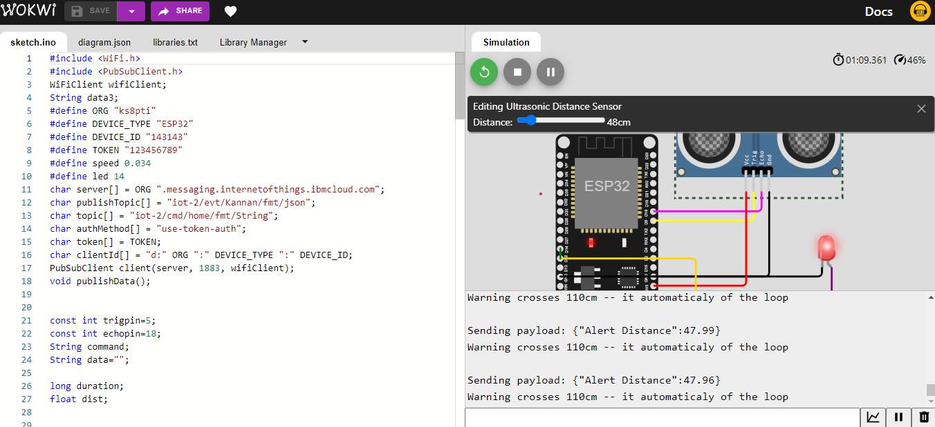

LED is on state

**IBM Cloud foundry connection**

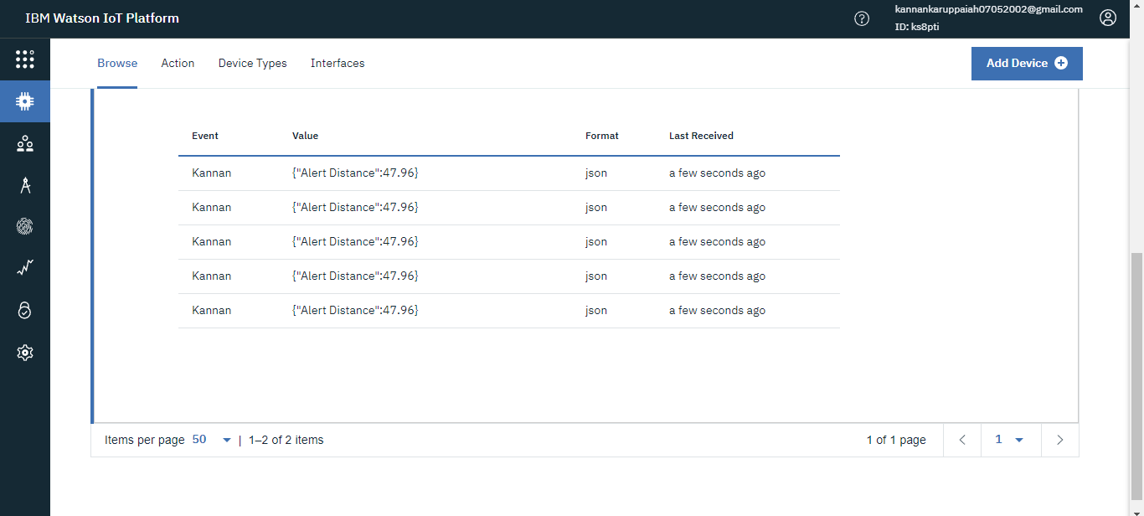

Getting alert message from wokwi